Procedure for Enabling SNMP in OPTRONIX OLTs, and OPTRONIX Support Team ContactNumbers
Franchisees using Optronix OLTs may either enable SNMP by following below mentioned procedure, or can contact the OPTRONIX SupportTeam for doing the same.
Command for Permitting SNMP
# login-access-list permit SNMP x.x.x.x (172.16.22.54 is Optronix EMS ip)
# login-access-list permit SNMP x.x.x.x (172.16.22.51 is BSNL NMS ip)

Web screenshot to allow SNMP towards two servers Optronix EMS 172.16.22.54 and BSNL NMS 172.16.22.51
Allow SNMP towards Optronix EMS 172.16.22.54 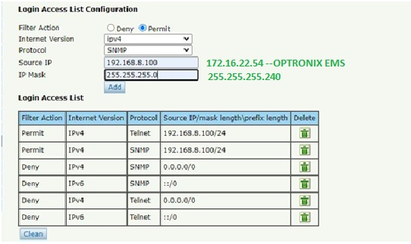
Allow SNMP towards BSNL NMS 172.16.22.51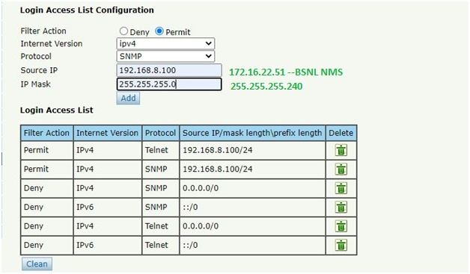
OPTRONIX Support Team ContactNumbers
Sl. No. | Technical Person Name | Contact No.
1. | Mr. Manish Gulia | +91 8287959915
2. | Mr. Ajay Singh | +91 8287959916
3. | Mr. Dhurv | +91 8287959917
4. | Mr. Harjeet Singh | +91 8287959919

